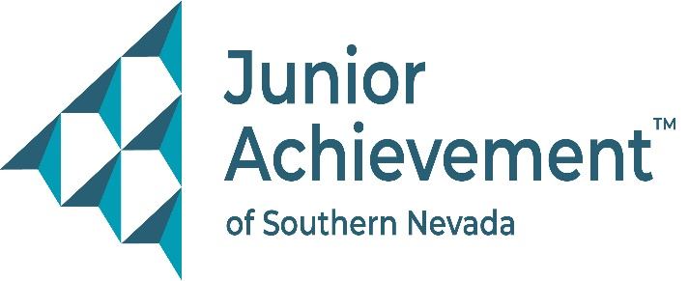
Date
FOR IMMEDIATE RELEASE:

Junior Achievement of Southern Nevada Welcomes Matt Cook of Cragin & Pike to Board of Directors


LAS VEGAS – Junior Achievement of Southern Nevada (JASN) is proud to announce the appointment of Matt Cook, executive vice president and shareholder at Cragin & Pike, to its board of directors. A longtime advocate for community engagement, Cook brings over two decades of experience in insurance, risk management, and agency leadership to the financial literacy nonprofit’s mission of preparing young people for economic success.
Cook joined Cragin & Pike in 2004 and currently oversees agency management, operational direction, client relations, new business, and the firm’s Claims and Risk Management department. A licensed agent in both property and casualty insurance, and health and benefits, his core expertise also includes agency operations – areas that all strongly align with Junior Achievement’s mission of financial literacy, workforce readiness and entrepreneurship. He has a Bachelor of Arts in Communication and Journalism from the University of Northern Colorado in Greeley, Colo.
Cook previously served on the board of the Candlelighters Childhood Cancer Foundation for 11 years, where he was Governance Committee chair, vice-chair, and chairman during the nonprofit organization’s 40th anniversary. Now, with his children grown and more time to give, he is eager to bring his insight and drive to Junior Achievement.
“Matt’s leadership experience, strategic mindset, and passion for community building make him a fantastic addition to our board,” said Michelle Jackson, JASN president and CEO. “His deep understanding of risk and operations, combined with a heart for service, will strengthen our ability to equip students with the tools they need to thrive in a rapidly changing world.”
Cook moved to Las Vegas in 2004 and proudly calls Nevada home. He was introduced to JASN through business partner and past JASN board member, Dulcinea Rongavilla, and sees this new role as an opportunity to continue making a meaningful impact in the Southern Nevada community.

About Junior Achievement of Southern Nevada
Founded locally in 1996, Junior Achievement of Southern Nevada, Inc. is dedicated to providing financial education to K-12 students and young adults with a curriculum including wants vs. needs, budget management to economic principals, workforce skills, credit and entrepreneurship. The completion of the new 40,000-square-foot Junior Achievement of Southern Nevada Inspiration Center will allow the nonprofit organization to impact more than 60,000 local youth. It is now the permanent site for capstone programs, Betty’s JA BizTown and JA Finance Park. Junior Achievement of Southern Nevada’s financial literacy mission is accomplished with the support of 285 businesses and 6,800 business role models, who help youth learn about the “business of life,” by helping bridge the gap between what youth learn in school and the real world. For more information visit https://jasnv.org/ and follow on Instagram and Facebook.

# # #

MEDIA CONTACT:
Nancy Katz, Purdue Marion & Associates, 702-349-0063 or nancy@purduemarion.com

